TKR College of Engineering & Technology (Autonomous)
Department of Computer Science and Engineering
CSE-A | Batch A11 (CSE, Section A)
AutoSecAI: Autonomous Pull Request Analysis for Security, Vulnerability Detection, and Code Quality using Multi-Agent LLMs
(AutoSecAI)
S.No. | Student name | Roll / hall ticket no.
1 | CHEPURI RISHIVARDHAN | 23K91A0553
2 | BODA SANDEEP | 23K91A0539
3 | DHARAVATH SEETHARAM | 23K91A0562
4 | NARISIMHA REDDY | 24K95A0501
Under the guidance of: P. KISHORE, [DESIGNATION]
BLOCK DIAGRAMS
This document collects every design diagram of AutoSecAI. Each diagram was drawn from the real code, the database tables and the routes and is followed by a paragraph that explains it. The diagrams were generated by scripts/make_diagrams.py with matplotlib.
Table 1: Diagrams in this document
No. | Diagram | Shows
1 | System architecture | Layers: browser, React web app, FastAPI backend, engine modules, storage, optional external services
2 | High-level workflow | Ten steps from sign-in to the review, plus the codebase and Model Lab paths
3 | DFD level 0 | Context: AutoSecAI and its external entities
4 | DFD level 1 | Six processes and six data stores
5 | DFD level 2 | Expansion of the seven-agent review process
6 | Use-case diagram | Actors and their use cases
7 | Sequence diagram | Starting a review, polling the job and reading the result
8 | ER diagram | Two SQLite databases and the JSON structure of a review
9 | UML class diagram | Domain types, engine classes and the backend job table
10 | Algorithm flowchart | Control flow of review_changes() down to the verdict

1 System Architecture
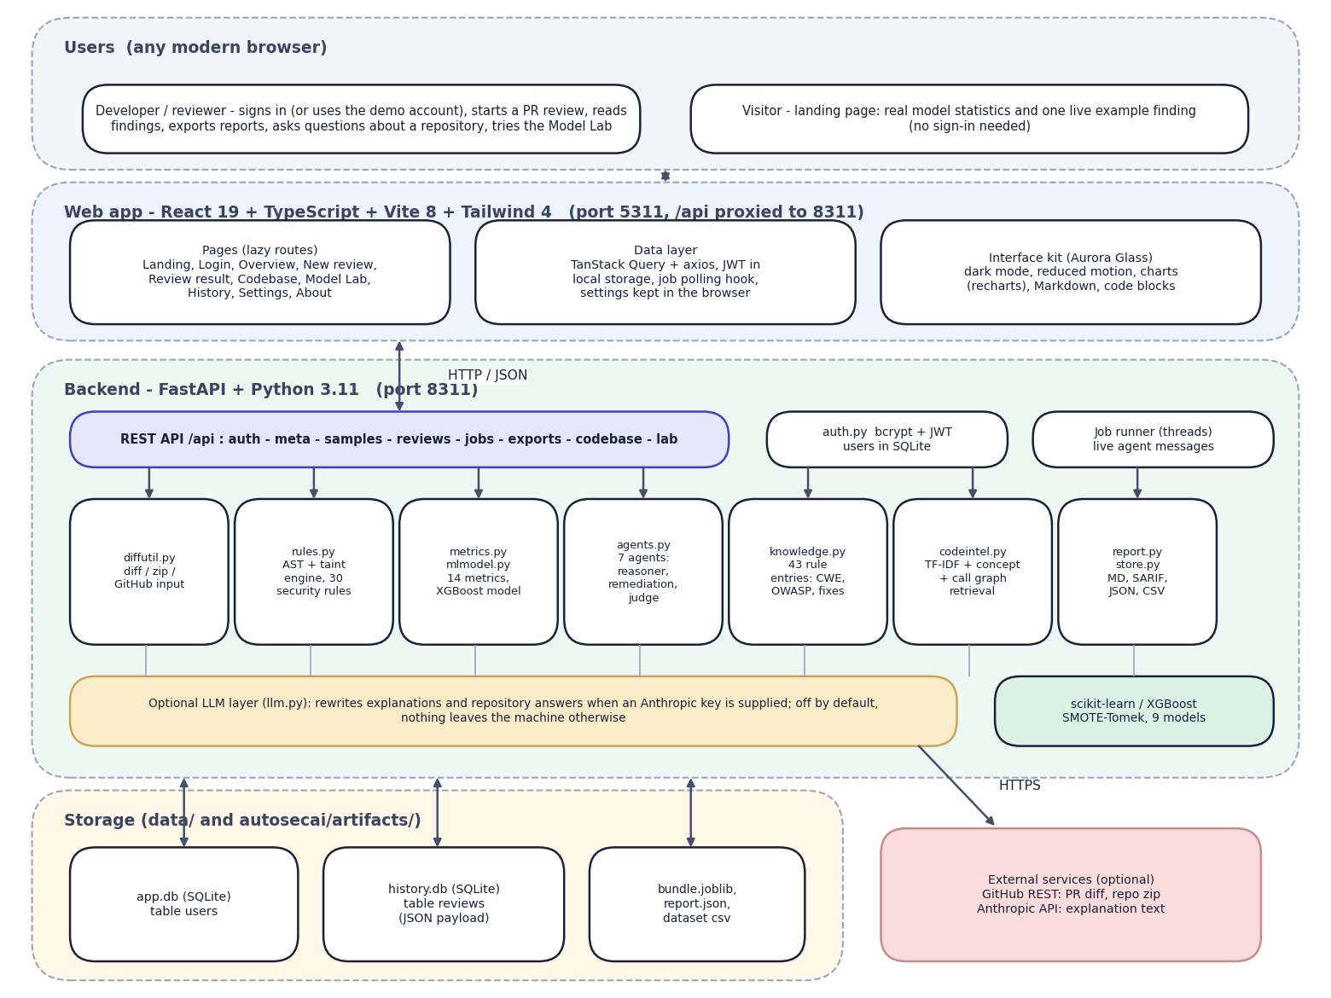
Fig. 1: System architecture of AutoSecAI
The diagram shows five bands. At the top are the users: a developer who signs in (or uses the seeded demo account) and a visitor who sees only the public landing page. Below is the React 19, TypeScript, Vite 8 and Tailwind 4 web application on port 5311, with lazily loaded pages, a data layer (TanStack Query and axios) that attaches the JWT and polls background jobs, and the Aurora Glass interface kit.
The backend band is a FastAPI application on port 8311. A REST layer exposes authentication, metadata, reviews, jobs, exports, the codebase assistant and the Model Lab; beside it sit auth.py (bcrypt and JWT) and the thread-based job runner. Beneath it are the seven engine modules that already existed: input handling (diffutil.py), the AST and taint rule engine (rules.py), metrics and model (metrics.py, mlmodel.py), the seven-agent pipeline (agents.py), the rule knowledge base (knowledge.py), repository retrieval (codeintel.py) and exporters and history (report.py, store.py).
The optional language-model layer (llm.py) is used only when an Anthropic key is supplied. Storage is local (app.db, history.db and the trained artefacts); the only external services are GitHub and, optionally, the Anthropic API.

2 High-Level Workflow
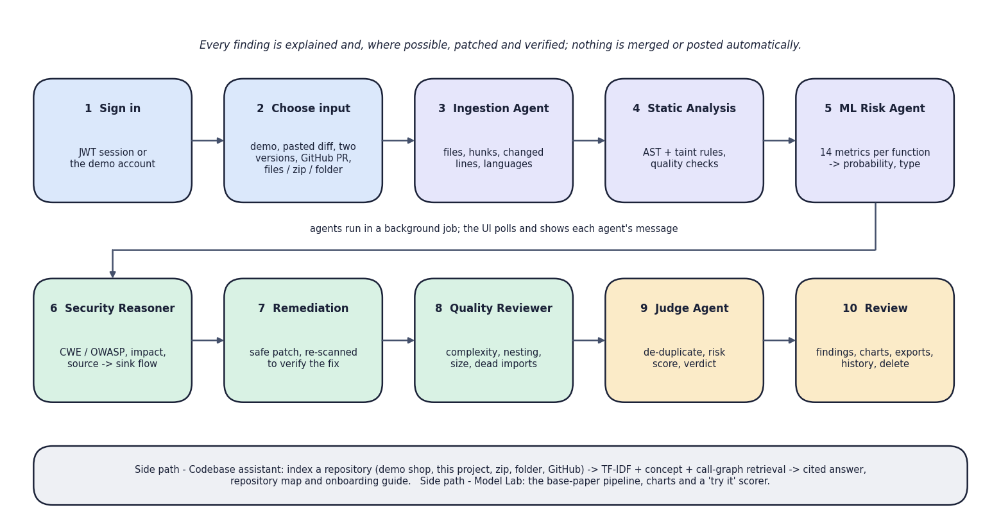
Fig. 2: High-level workflow
The ten steps run in two rows. Steps 1 and 2 are the user's: sign in and choose one of five inputs (the demo, a pasted diff, two versions of a file, a GitHub pull-request link, or files, a zip or a folder). Steps 3 to 9 are the seven agents: Ingestion, Static Analysis, ML Risk, Security Reasoner, Remediation, Quality Reviewer and Judge, run in a background job whose progress the interface polls. Step 10 is the review screen. The grey strip names the two side paths, the codebase assistant and the Model Lab, and the top line states the design rule that nothing is merged or posted automatically.

3 Data-Flow Diagram: Level 0
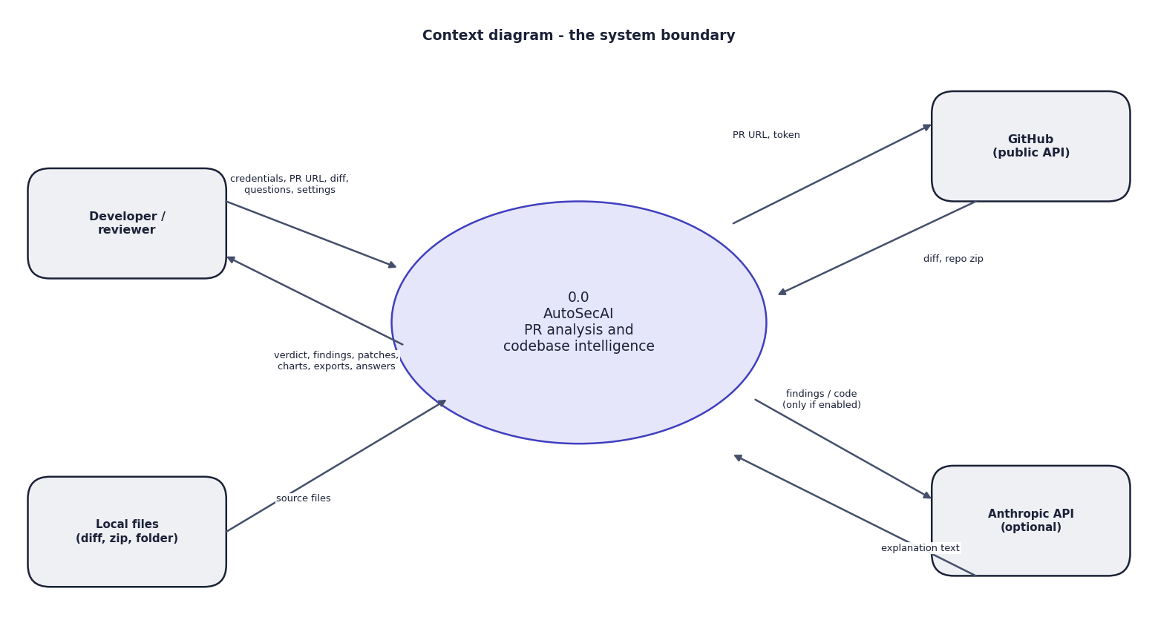
Fig. 3: Data-flow diagram, level 0 (context)
AutoSecAI is one process with four external entities. The developer sends credentials, pull-request URLs, diffs, files, questions and settings and receives a verdict, findings, patches, charts, exports and answers. Local files supply source code. GitHub returns a diff or a repository archive for a URL. The Anthropic API receives text only when the optional language-model mode is on.

4 Data-Flow Diagram: Level 1
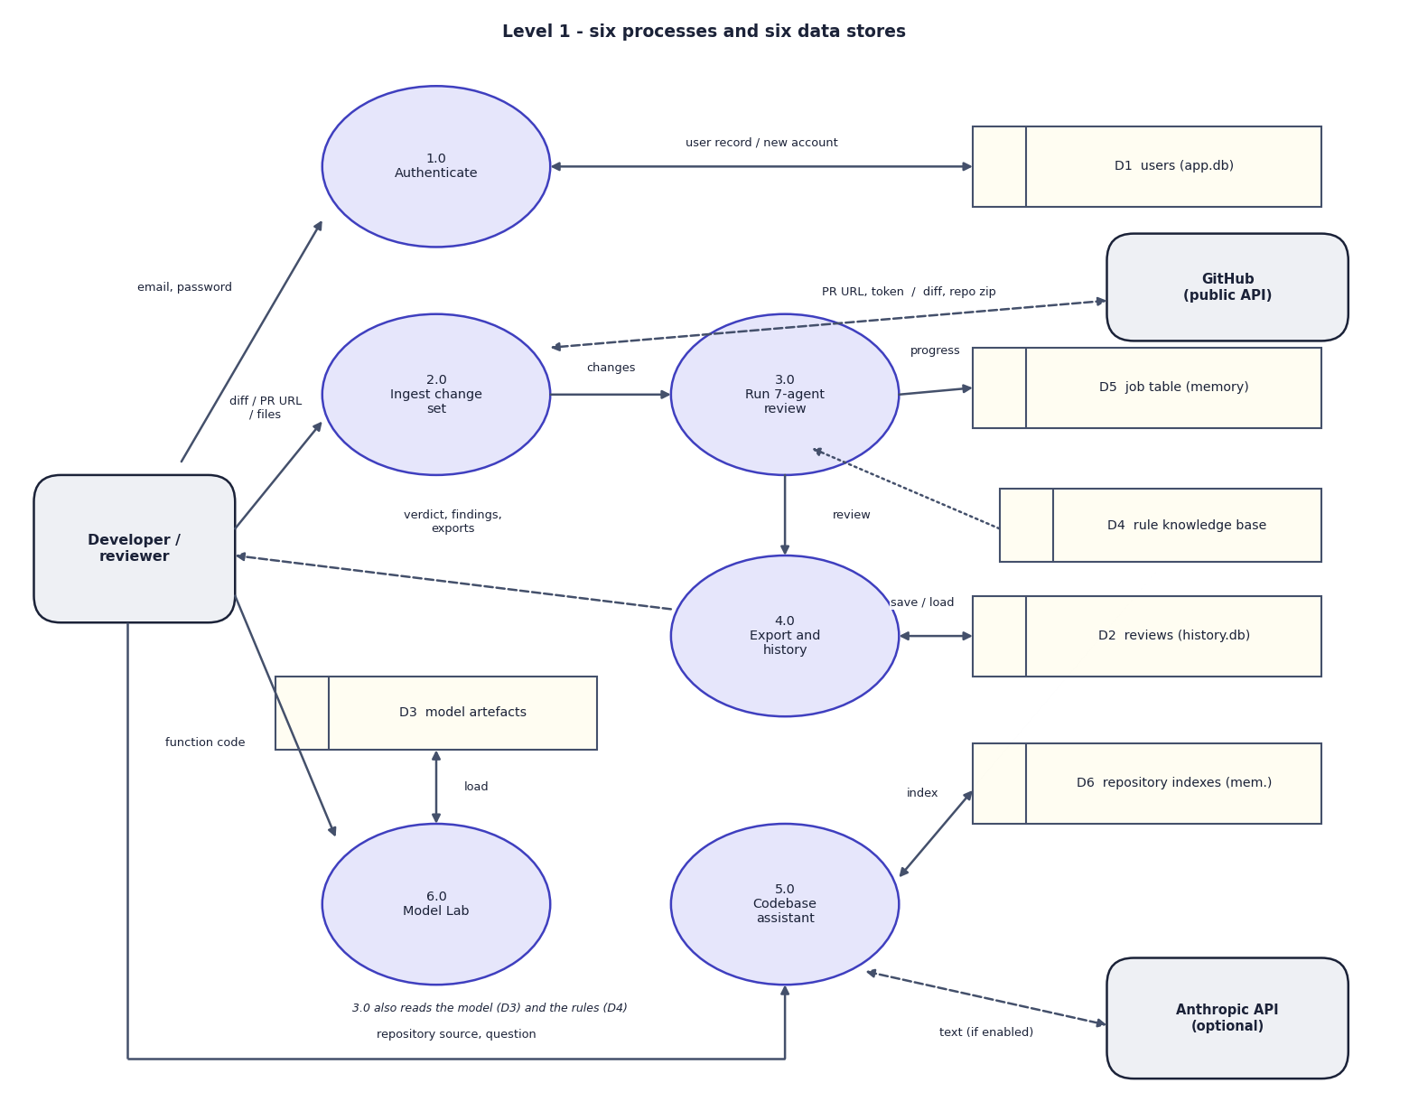
Fig. 4: Data-flow diagram, level 1
Level 1 has six processes: authentication (1.0), ingestion (2.0), the seven-agent review (3.0), export and history (4.0), the codebase assistant (5.0) and the Model Lab (6.0), and six stores: users (D1), reviews (D2), model artefacts (D3), rule knowledge base (D4), job table (D5) and repository indexes (D6). Every result that must survive a restart goes through 4.0 into D2, while jobs and indexes stay in memory; the Model Lab only reads the artefacts and never writes to the history.

5 Data-Flow Diagram: Level 2
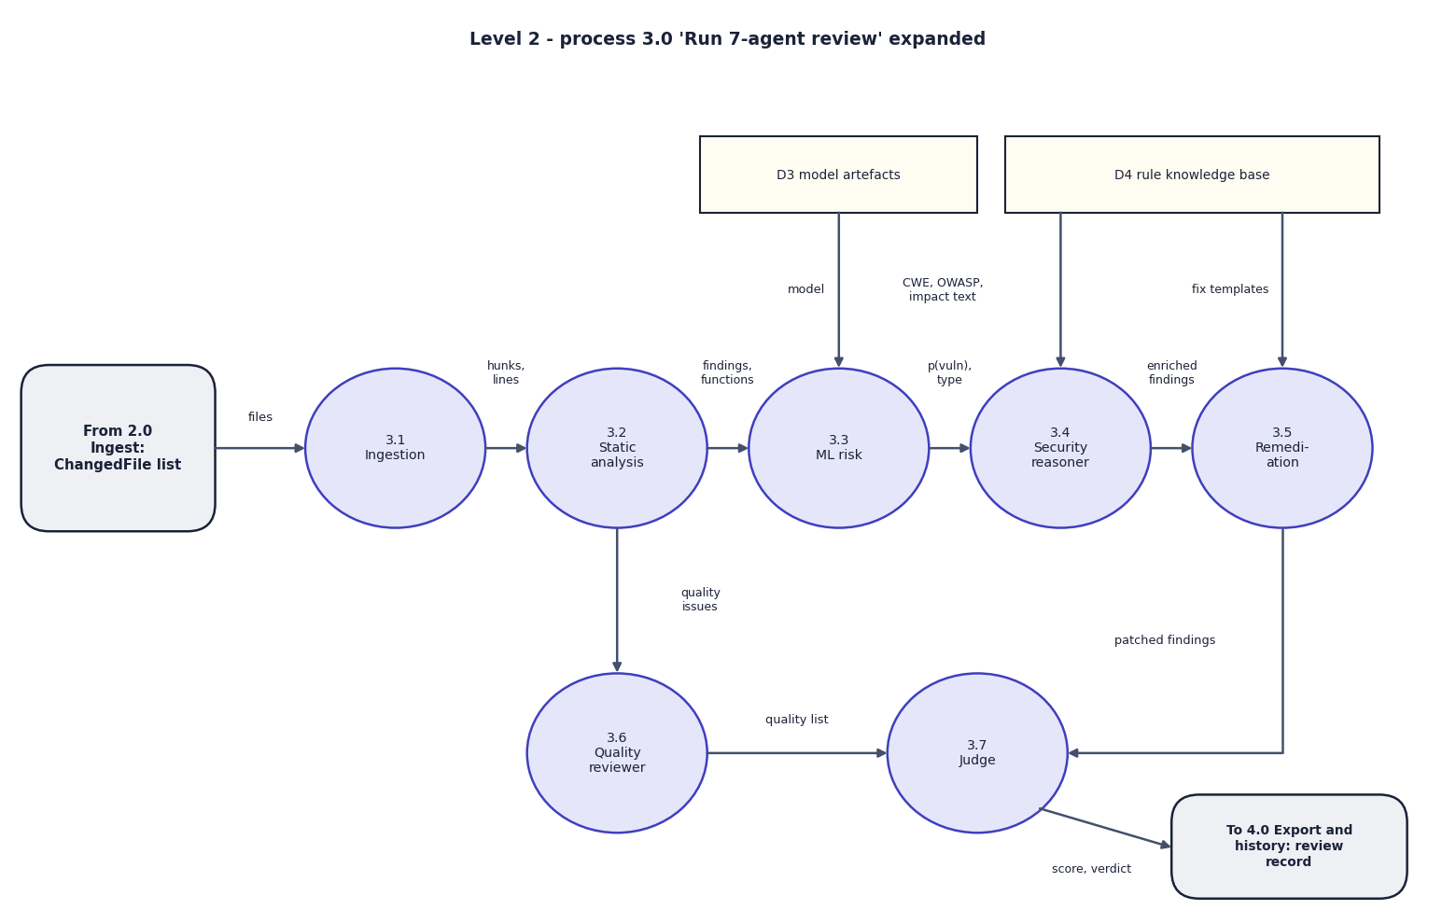
Fig. 5: Data-flow diagram, level 2: the seven-agent review (process 3.0)
Process 3.0 is expanded into its seven agents, following review_changes(). The change set enters ingestion (3.1); hunks and line numbers go to static analysis (3.2); findings and functions go to ML risk (3.3), which reads the model artefacts. The reasoner (3.4) reads the knowledge base for CWE, OWASP, impact and flow text, and remediation (3.5) reads the fix templates. Quality issues pass from 3.2 to the quality reviewer (3.6). The judge (3.7) de-duplicates, computes the score and verdict and hands the review record to process 4.0.

6 Use-Case Diagram
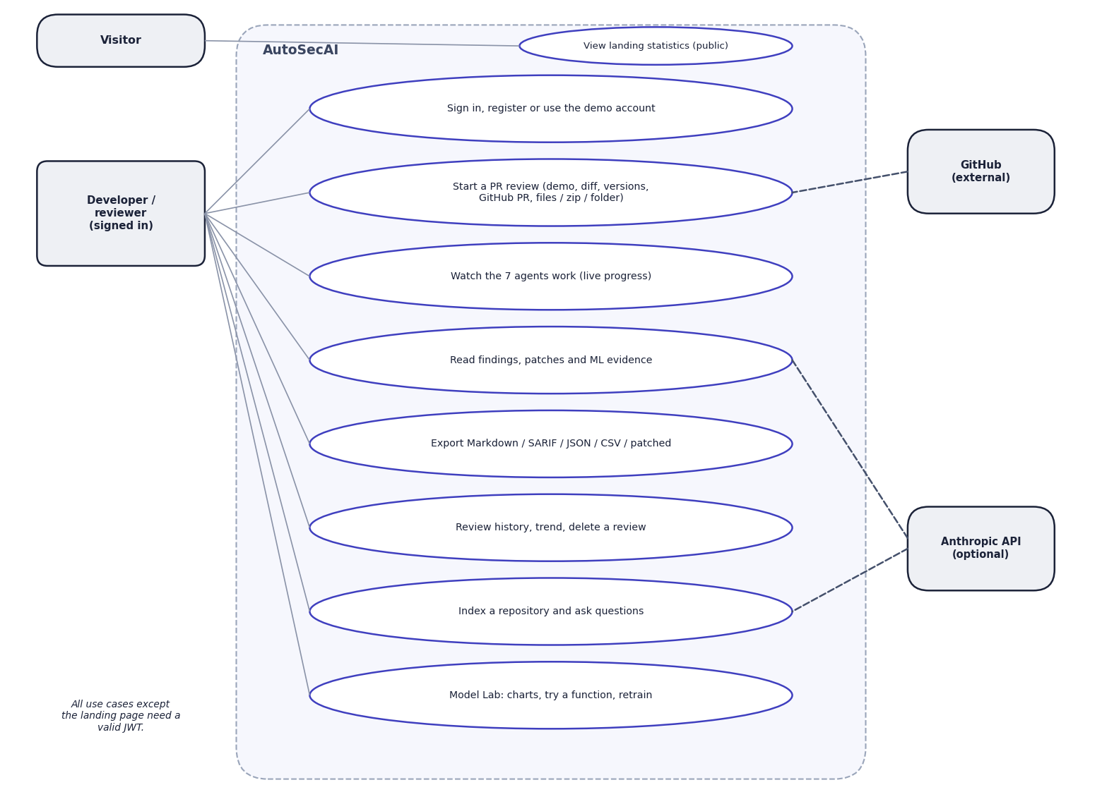
Fig. 6: Use-case diagram
The signed-in developer has eight use cases: sign in, register or use the demo account; start a review through any of five inputs; watch the agents work; read findings, patches and ML evidence; export Markdown, SARIF, JSON, CSV or patched files; use the history; index a repository and ask questions; and use the Model Lab. A visitor can only view the landing statistics. GitHub attaches to starting a review and the optional Anthropic API to reading findings and repository questions.

7 Sequence Diagram
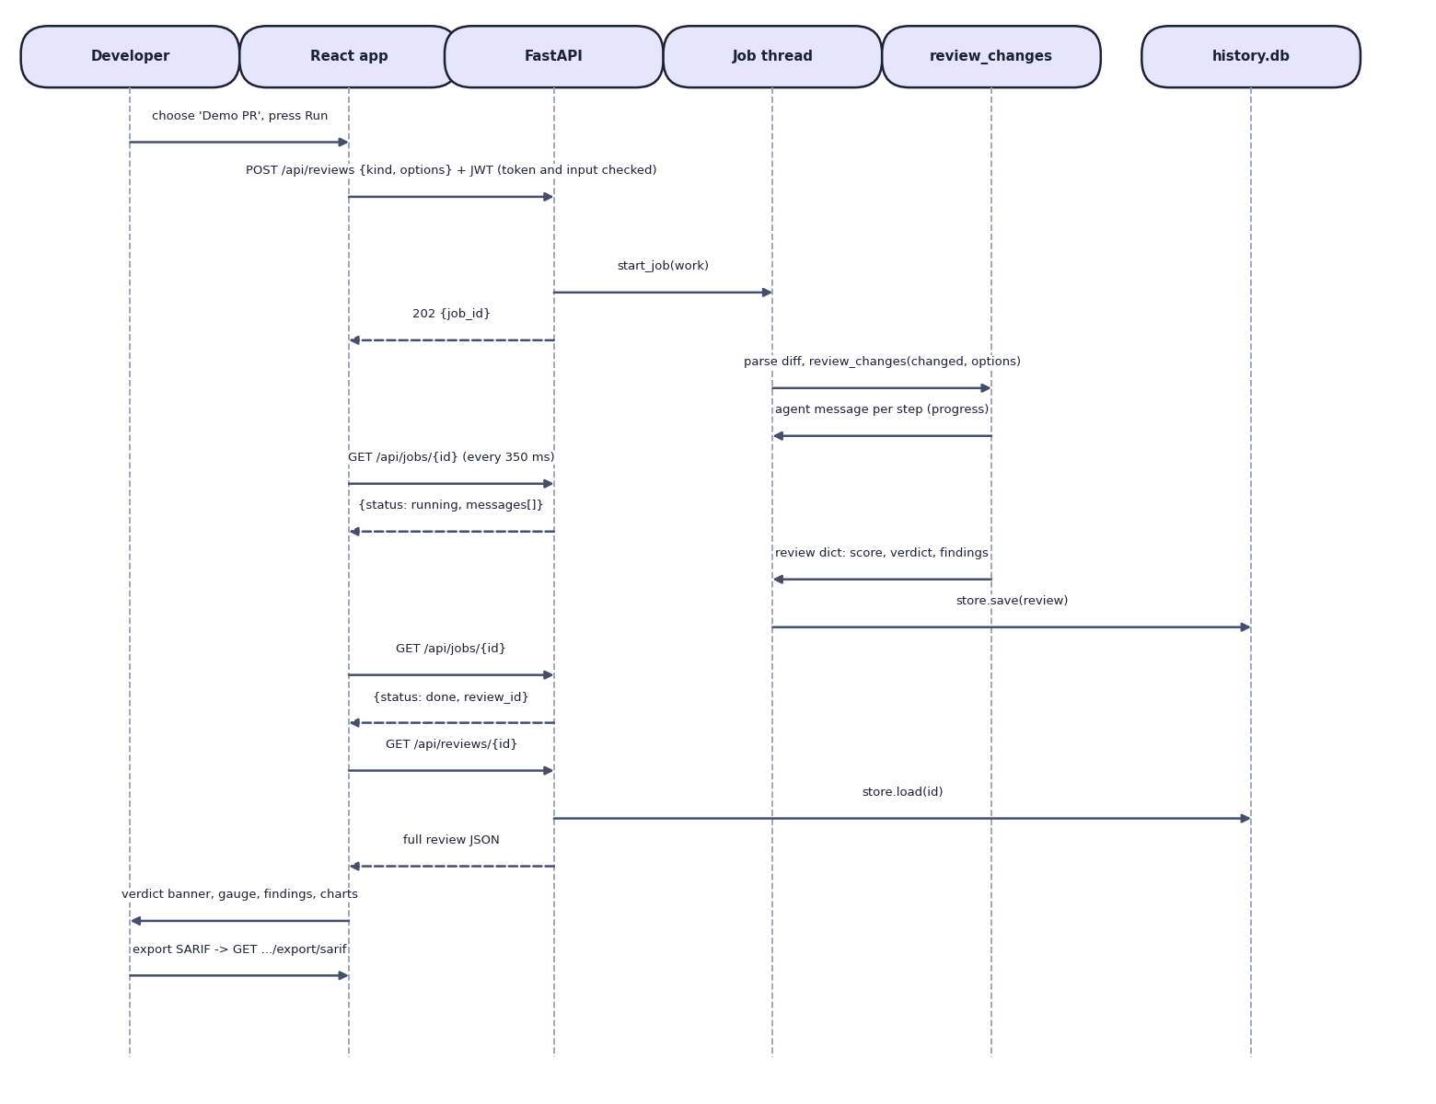
Fig. 7: Sequence diagram: running a review and opening the result
The participants are the developer, the React app, FastAPI, a job thread, review_changes and the history database. The app posts the request with the JWT; FastAPI checks the token and input, starts a job and answers 202 with a job identifier. The job thread runs review_changes, which reports one message per agent, while the app polls the job and receives running with the messages so far. When the review is saved the next poll returns done; the app loads the whole review and shows it, and the last arrow requests an export. The polling interval of the implemented hook is 350 ms.

8 Entity-Relationship Diagram
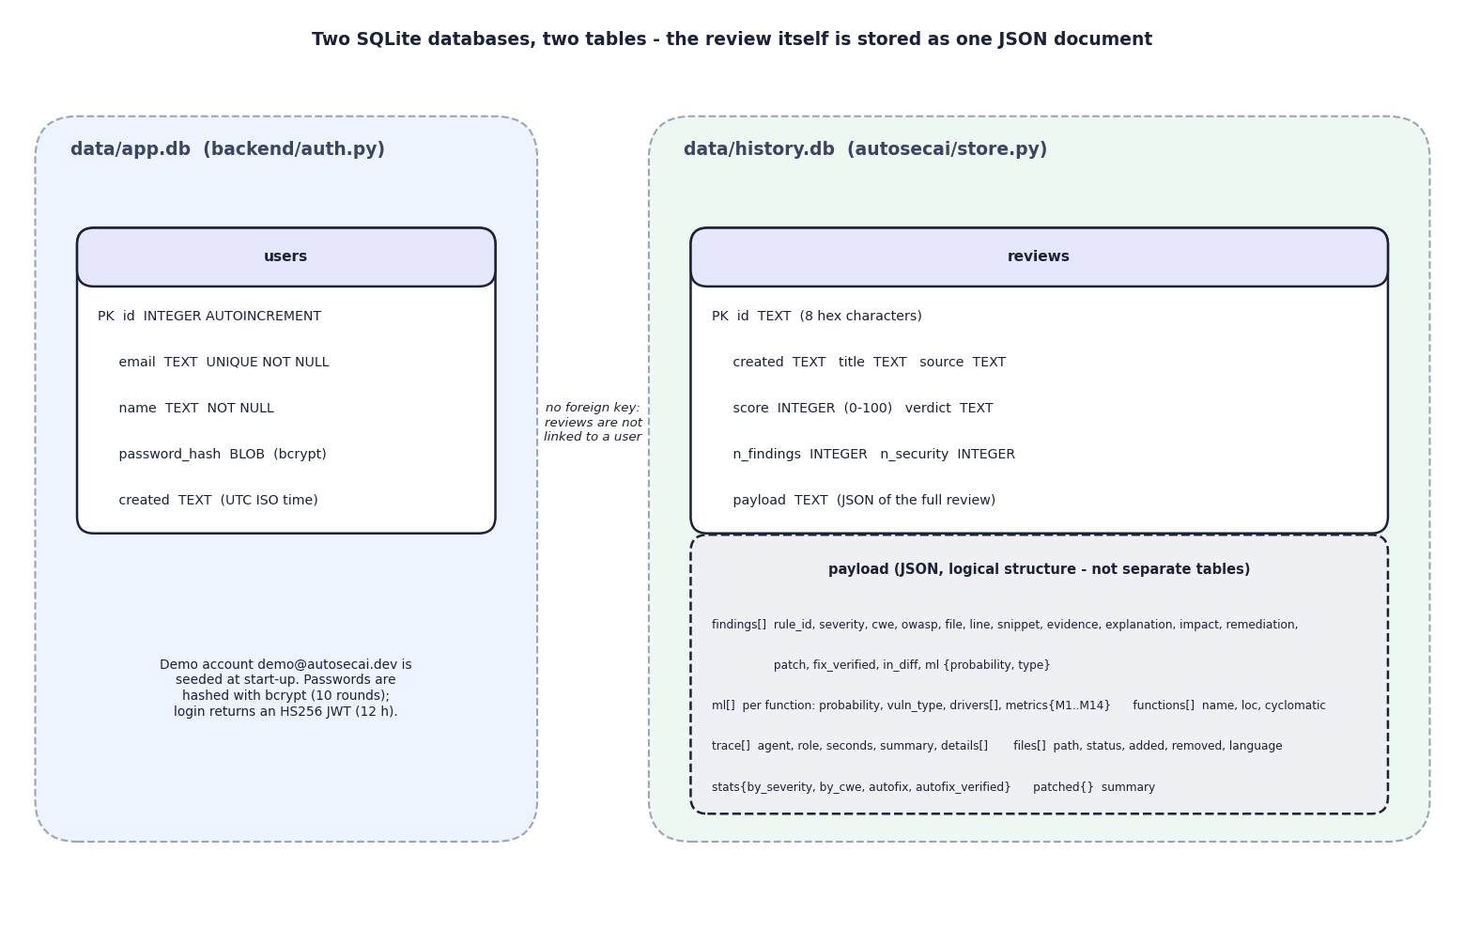
Fig. 8: Database design: two SQLite files
The file app.db holds one table, users (key, unique e-mail, name, bcrypt hash, creation time). The file history.db holds one table, reviews (eight-character identifier, creation time, title, source, score, verdict, two counters) and a payload column with the complete review as JSON. The lower box lists the logical parts of that payload (findings, ML rows, trace, files, statistics, patched files), which are not separate tables. The dotted note records a limitation: the tables are not linked, so a review has no user identifier and the history is shared by all accounts.

9 UML Class Diagram
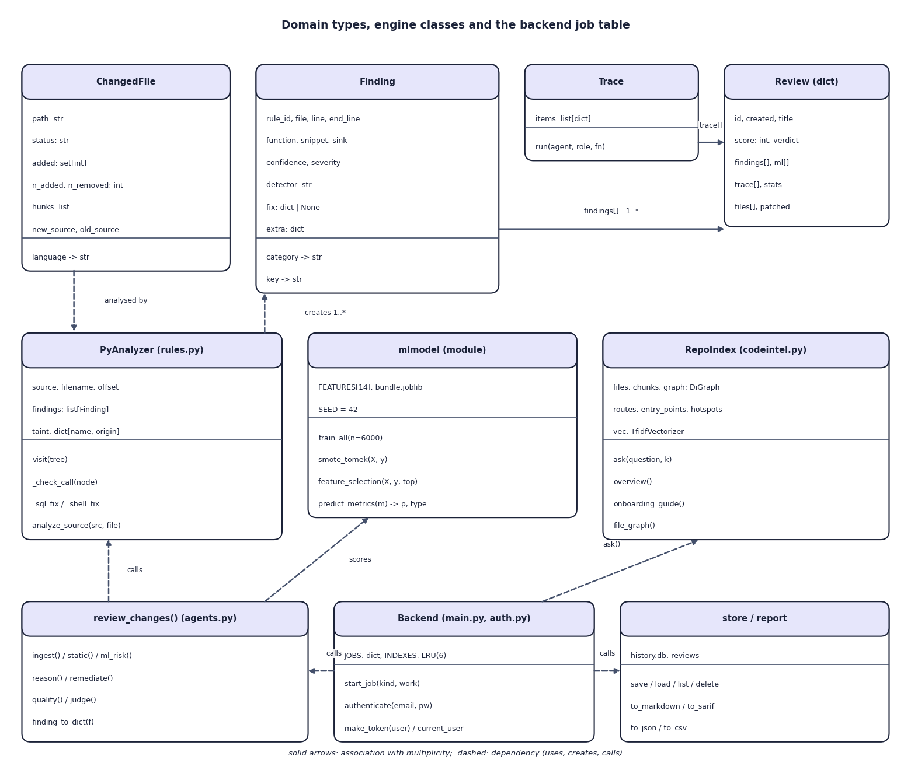
Fig. 9: UML class diagram
The upper row shows the domain types: ChangedFile, Finding (rule, location, confidence, severity, optional fix), Trace and the review record. The middle row shows PyAnalyzer, which walks the syntax tree and creates findings, the model module, and RepoIndex with its chunks, graph and TF-IDF matrix. The bottom row shows review_changes() with its agent functions, the backend objects (the job table and the table of six repository indexes) and the store and report functions. Dashed arrows are dependencies; 1..* records that a review contains many findings.

10 Flowchart of the Core Algorithm
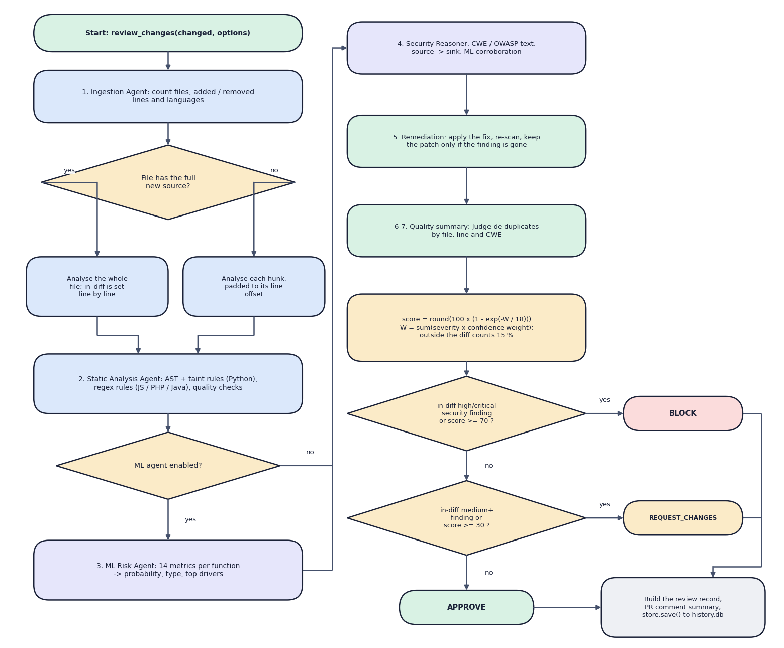
Fig. 10: Flowchart of the core algorithm, review_changes()
The left column shows the first half. After ingestion, a decision checks whether the full new source is known: if so the whole file is analysed and each finding is marked inside or outside the change; otherwise each hunk is analysed with its line offset. If the ML agent is enabled every function is scored. The right column continues with the reasoner, the remediation agent (apply a fix, re-scan, keep the patch only if the finding is gone) and the quality and judge step.
The score is round(100 x (1 - exp(-W / 18))), with W the sum of severity times confidence weights and findings outside the change counted at 15 %. A high or critical security finding in the change (medium or higher confidence), or a score of 70 or more, gives BLOCK; otherwise a medium finding in the change, or a score of 30 or more, gives REQUEST_CHANGES; otherwise APPROVE. The record is then saved to the history.

